Arduino project: ultrasonic sensor HC-SR04

Project description:

- The project has the purpose of measuring, in cm, the distance from the ultrasonic sensor to an object. The two LED-s can announce when the object is to close.
- In my example, the green LED will remain on when the distance is greater than 10 cm or lower than 5 cm. Between these two values, the red LED will become on.
- This project can be associated with a small explanation of how, for example, car parking-sensors actually work, by emitting sound waves which travel through air.
Of course, it can be made in a more advanced way, by adding a display that shows the distance, so that a full size monitor would not be necessary anymore

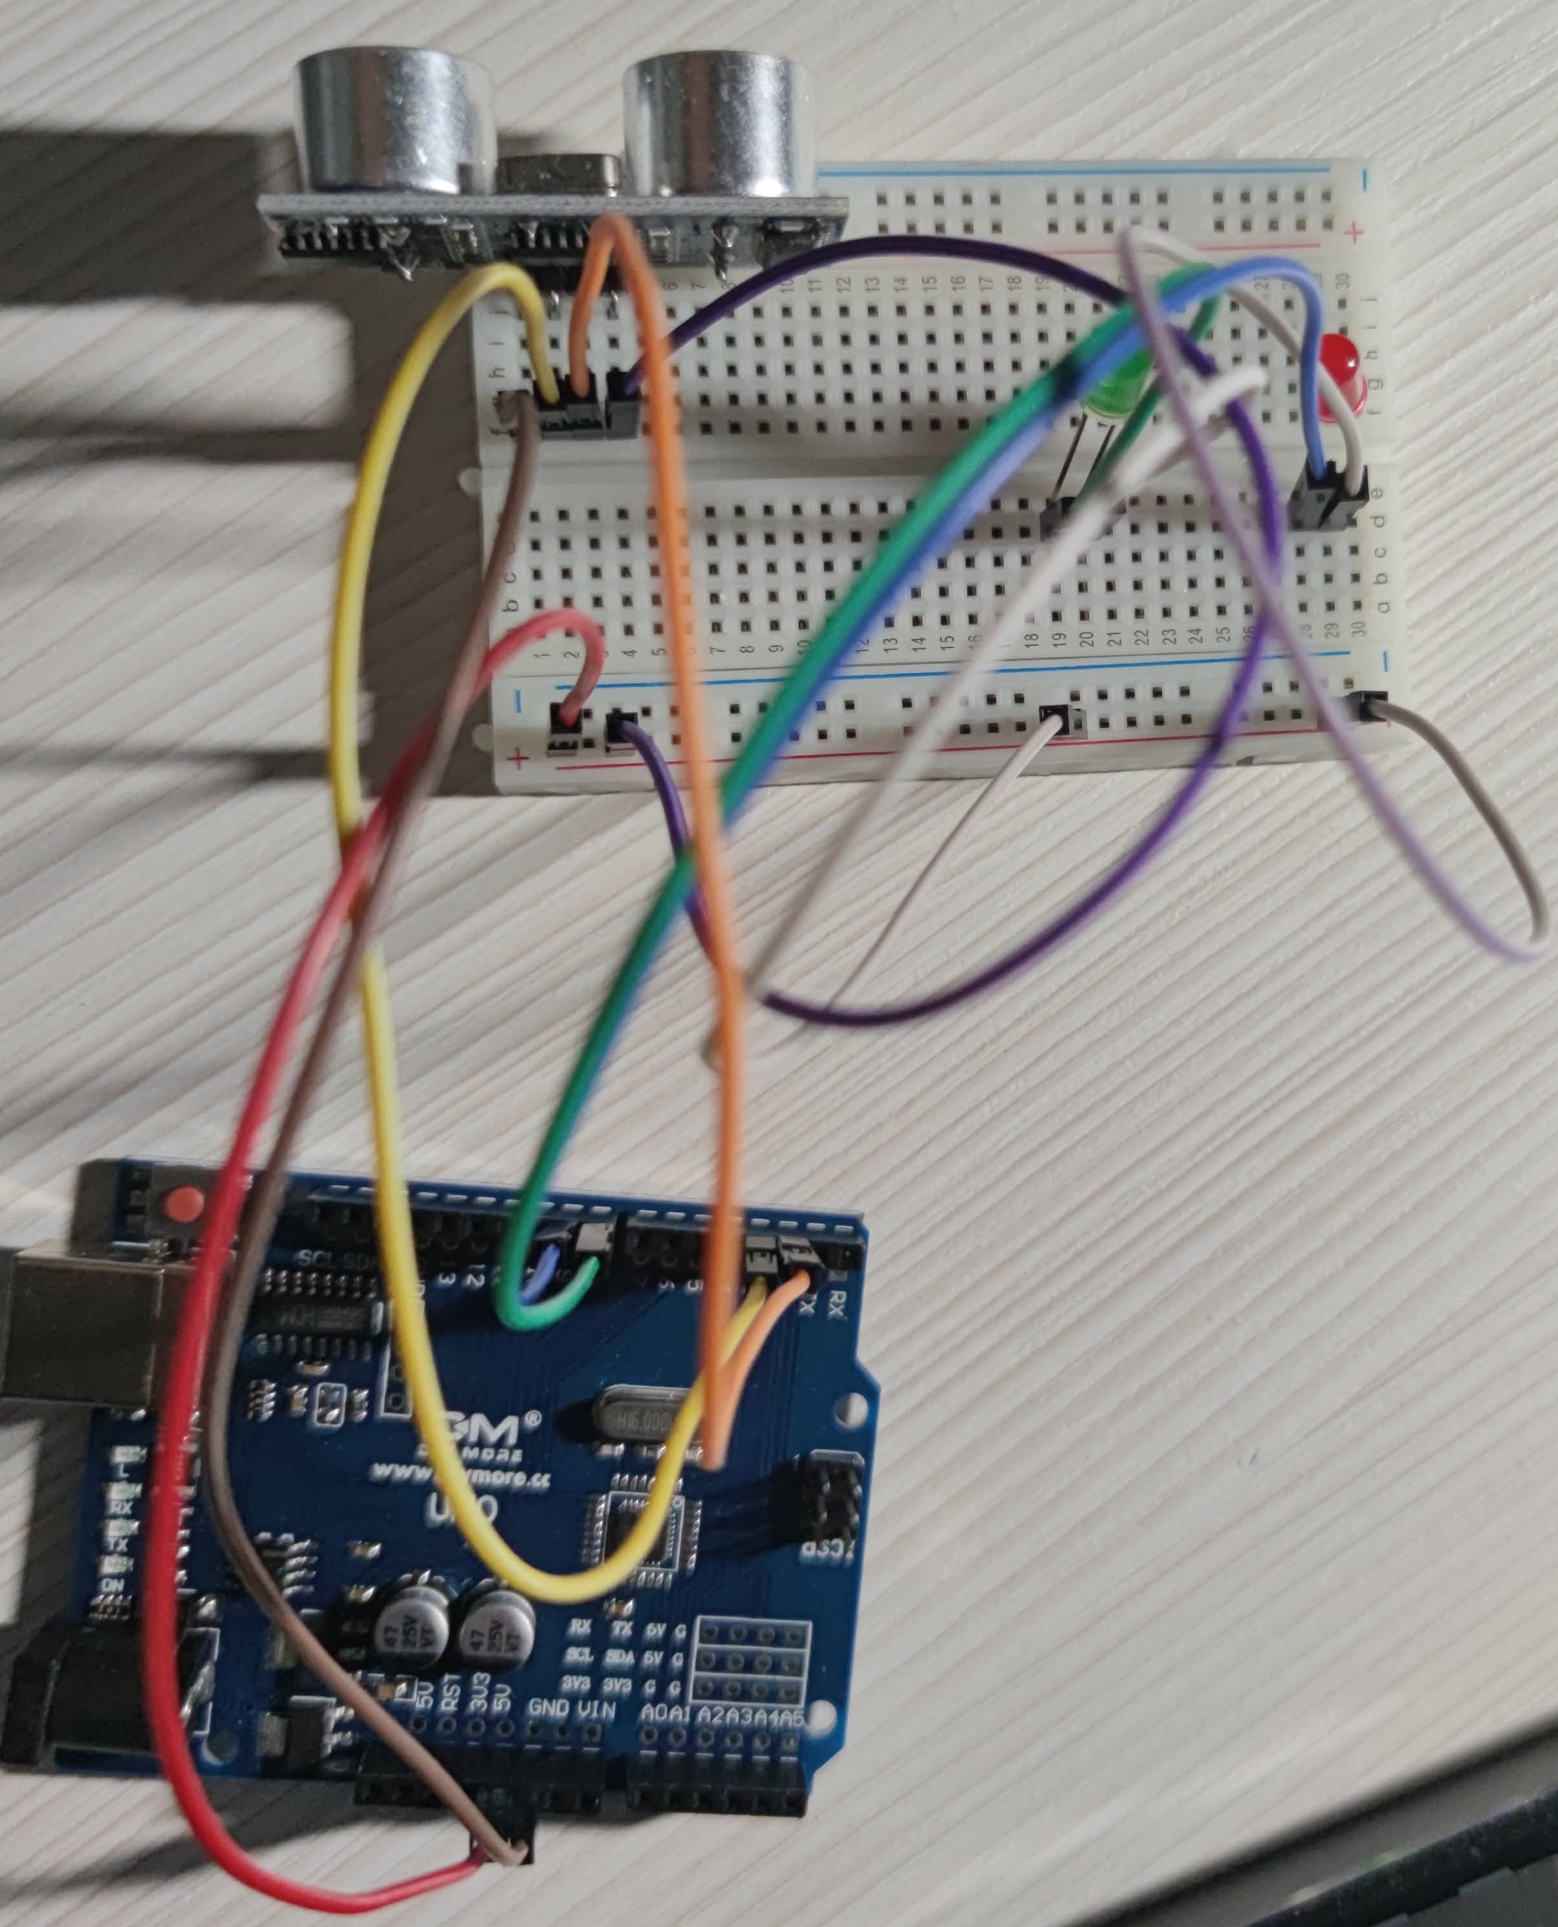
Schematics:
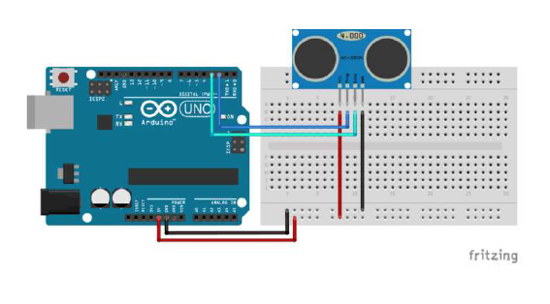

Requisites:

- Arduino UNO
- Senzor ultrasonic HC-SR04
- Led 3mm
- Set fire pentru Breadboard
- Breadboard

Setup and build

HC-SR04 Arduino
VCC 5 V
Trig Pin 2
Echo Pin 3
GND GND

Running / Code

The module emites a sonic pulse of 8 cycles with 40kHz. For this, pin Trig should be set at a HIGH level for at least 10 µs after a clean GUGH has been assured by setting pin at LOW level

digitalWrite(trigPin, LOW);
delayMicroseconds(5);
digitalWrite(trigPin, HIGH);
delayMicroseconds(10);
digitalWrite(trigPin, LOW);

The module sets the Echo output signal on 5V and the minicontroler starts the stopwatch for synchronization.
The sound waves are sent and reflected on objects and the first reflection (echo) is considered to be given by the closest object.
The firs echo received determines the module to set the Echo output signal to 0V.

Duration=pulse(ECHO_PIN, HIGH)
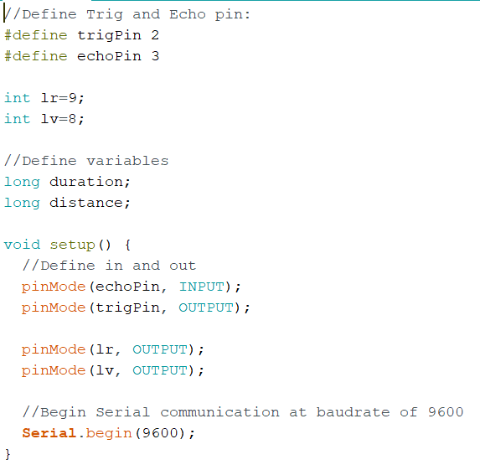

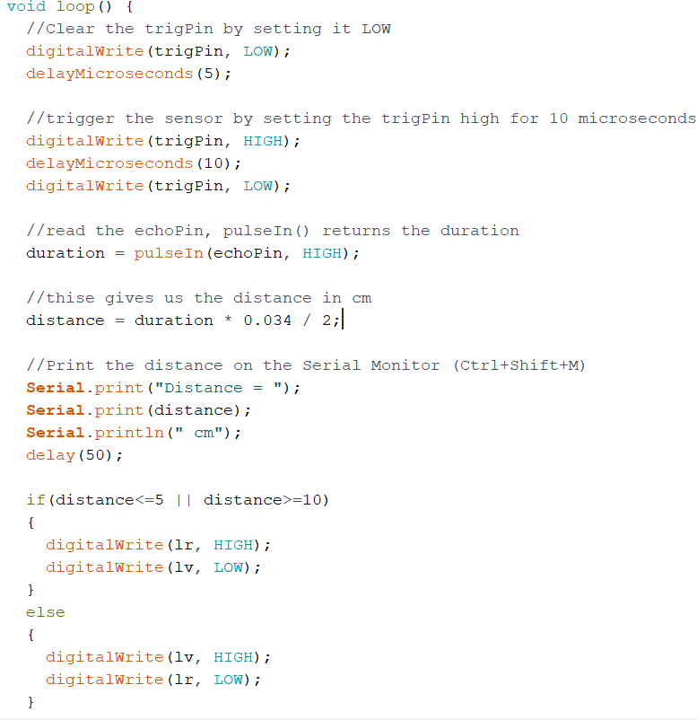

Helpful links

https://www.makerguides.com/hc-sr04-arduino-tutorial/

